Promises chaining

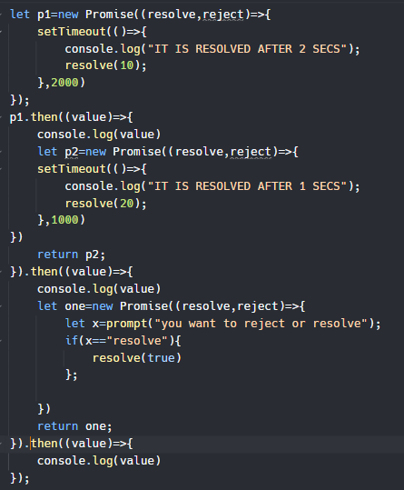.

promise chainingmein jo new promise hai wo then ke ander likhna hai , then ke end honay se pehlay pehlay okie or usse then ke ander he resolve bhi krna hai or fir uss then ke endmein naya then . kr ke lagana hai or fir aagay mazeed promises chain krnay hain

## Automatic promise creation// and direct promise creation

## 

Jss aap then ke ander sirf return kr ke koi value de do tu wo automatically browser usse ek new promise mein convert kra kr next .then() ke ander uske value ko print krwa de ga .

### Direct Promise creation

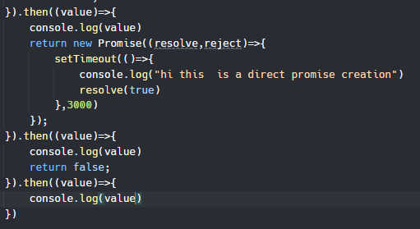

**Hum harr ek .then() se ek new promise resolve krwatay rehein ge or iss se callbackHell wali problem resolve kr lein gay//bar bar call back ke bad fir callback call krny ke zarurat nahi prh rhi hamein**